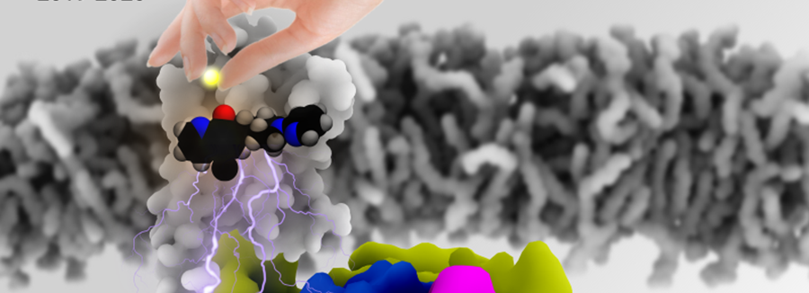
The First Greater Bay Area (BGA) Biophysics and New Drug Discovery Forum
April 10-12, 2021, ZhuHai
第一届大湾区生物物理与新药发现论坛
2021年4月10-12日 珠海

参会注册信息确认表
Registration confirmation form

(1) Your name (姓名)：Click or tap here to enter text.
(2) Title (职称/职务)：Click or tap here to enter text.
(3) Affiliation (工作单位)：Click or tap here to enter text.
(3) Date of arrival （抵达珠海时间）：☐4.9 ☐4.10 ☐4.11 ☐4.12
(4) Will you take students or colleagues to join the event? 您是否带学生或者同事一起参会？
☐No ☐Yes
(5) If yes for question 3, how many students or colleagues will you take? Please list their names as well如果带，您会带几个学生或者同事过来？请列举出他们的姓名。
☐1 ☐2 ☐3 ☐4
Name of Students to attend 参会学生或同事姓名 Click or tap here to enter text.
(6) Will you join the tour in Zhuhai on 4.12? 您是否参加4月12日的珠海游览吗？
☐No ☐Yes

The registration fee for student is 300 RMB/person which covers meals for the meeting. Accommodations should be covered by yourselves. Students and postdocs should prepare a poster for the meeting。学生注册费用为300元人民币/人。此费用仅包含餐食，住宿自理。学生和博后需准备学术海报参加交流。
The price for regular adamic registration is 600 RMB/person for professors or postdocs. This only convers your meals. Accommodations should be covered by yourselves. A postdoc should prepare a poster for the meeting if you are not invited for the talk. 教授、博后普通学术注册费用为600元人民币/人。非大会演讲的博后需准备学术海报参加交流。

For registration, please contact Lisa: 15900770950 (Wechat & Telephone)
关于具体注册情况，请通过微信或者电话与Lisa女士联系：15900770950 （微信和电话）
Please send your confirmation form after transferring the registration fee: lijuan.yuan@alphamol.com
转账后请将转账凭证截屏发给Lisa女士: lijuan.yuan@alphamol.com

Payment information注册转账信信息
Account name帐户名：深圳阿尔法分子科技有限责任公司
Bank account账户号码：8110301013100556765
Opening Bank开户行：中信银行股份有限公司深圳香林支行
Address 公司地址：深圳市龙华区大浪街道同胜社区谭罗华荆路安宏基产业园（羊台山园区）1栋103

